**1. Write a shell script to define any four variables (of different data types) and display them using echo. For example:**

**myval=45**

**echo “Value of myval is $myval”**

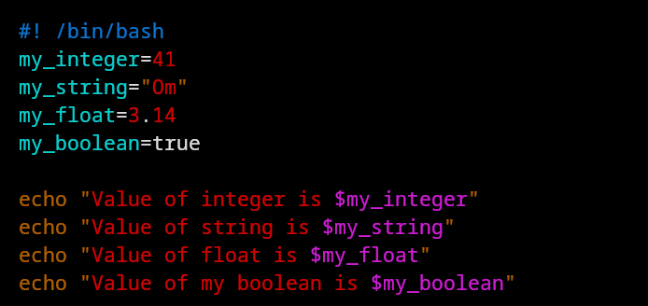

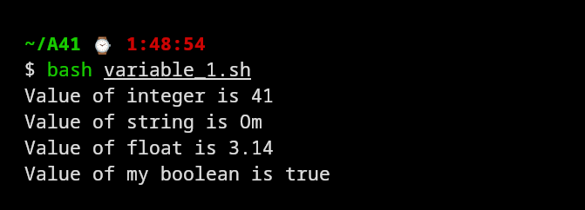

**2. Accept the age of the user from input. Write a shell script to determine if the user is eligible for voting.**

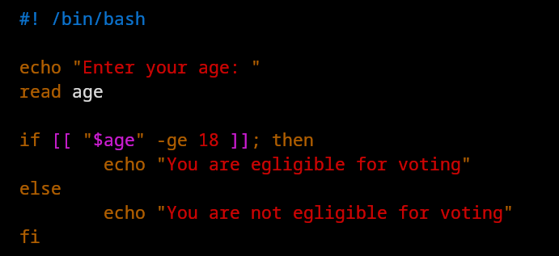

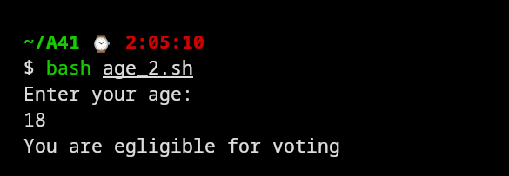

**3. Write a shell script that accepts two numbers from users. Display the addition, subtraction, multiplication, division (quotient), remainder results using echo; without and with expr.**

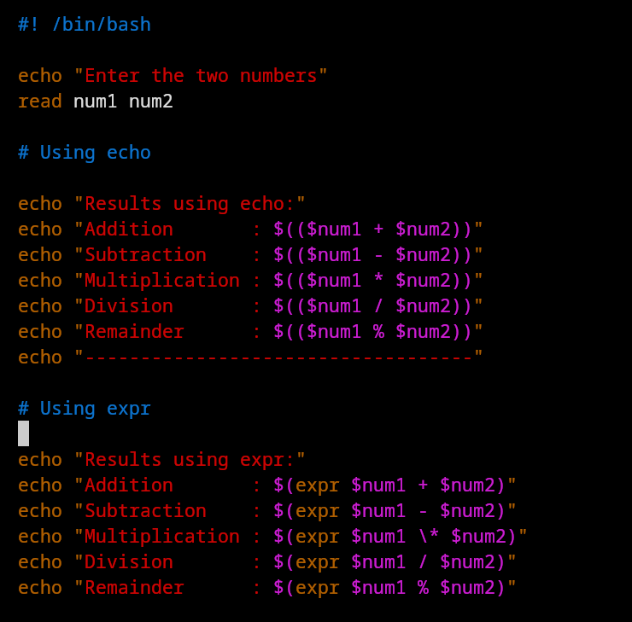

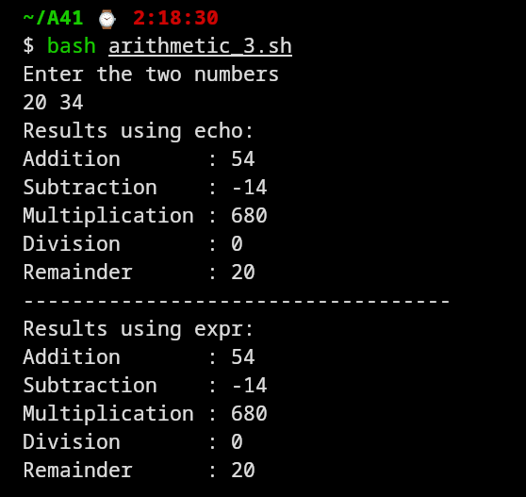

**4. Write a shell script to determine the maximum of three numbers.**

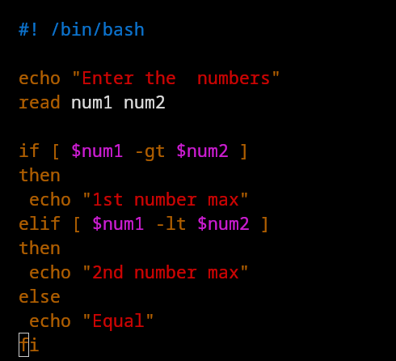

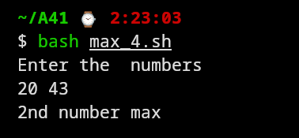

**5. Accept two strings from the user. Write a shell script to check if the two strings are the same or not.**

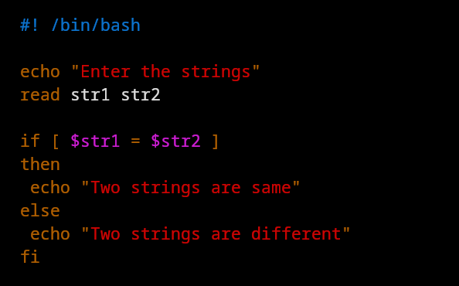

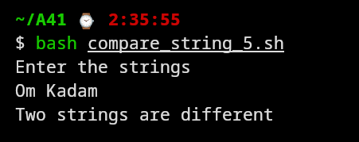

**6. Write a shell script to validate the course marks using nested if and specify the class.**

**Accept marks for three courses – Physics, Chemistry, Mathematics. Compute the total marks and average marks. If any course has less than 35 marks, display “Failed”. If the**

**average marks is >= 75, display “Distinction”. If the average marks is >=60 but <=75,**

**display “First Class. If the average marks is >=50 but <=60, display “Second Class. If the**

**average marks is >=35 but <=50, display “Third Class.**

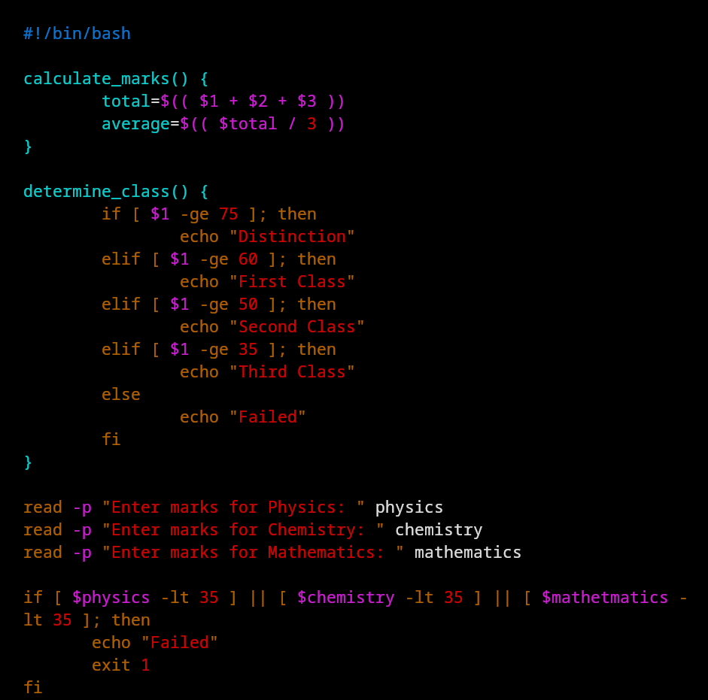

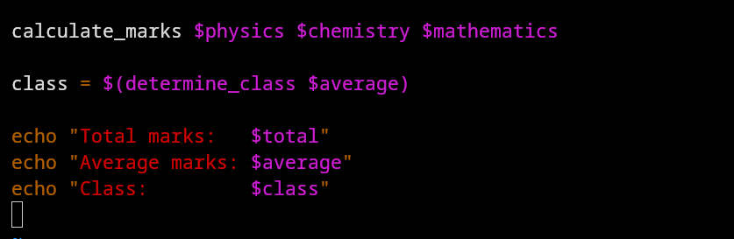

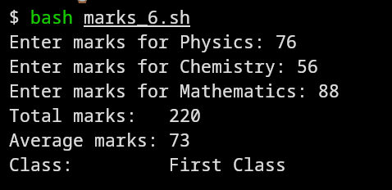

**7. Display “Linux” i times, where i goes from 1 to 8. Demonstrate using while loop and for loop.**

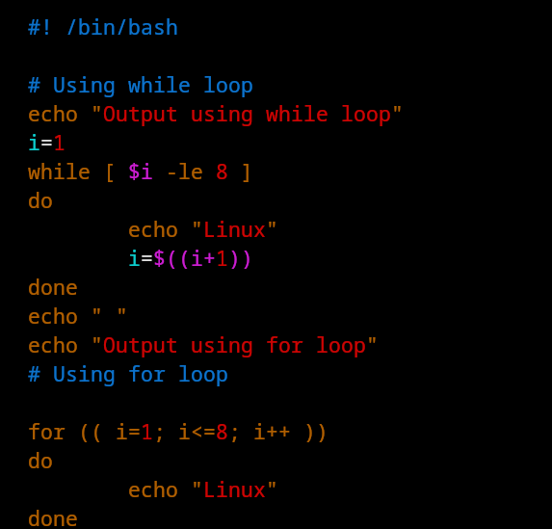

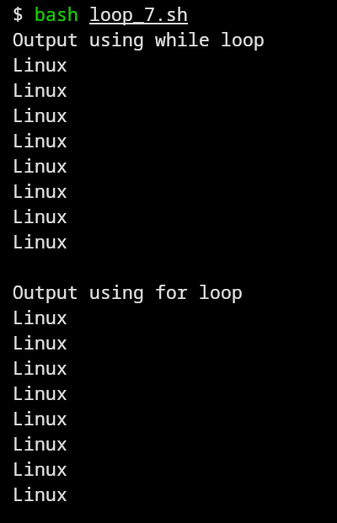

**8. Write an infinite loop using for loop (use CTRL + C to exit).**

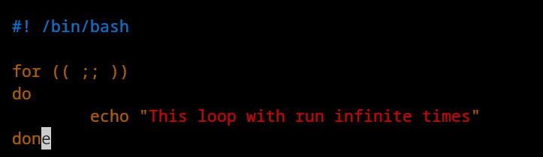

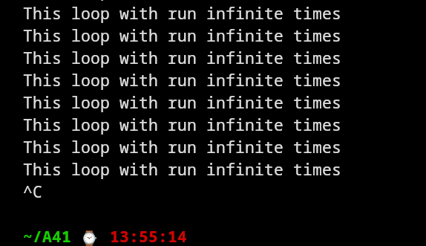

**9. Write a shell script to print a number in reverse order using a while loop. It should support the following requirements. The script should accept the input from the command line. If you don’t input any data, then display an error message to execute the script correctly.**

**Hint:**

**a. Suppose the input number is n.**

**b. Set reverse to 0 and digit to 0 (i.e., rev=0, digit=0).**

**c. The expression (n % 10) will give the single leftmost digit i.e., digit.**

**d. To reverse the number, use this expression rev * 10 + digit.**

**e. Decrease the input number (n) using n / 10.**

**f. If n is greater than 0, then go to step no. 3. Else, execute the step no. g.**

**g. Print the result.**

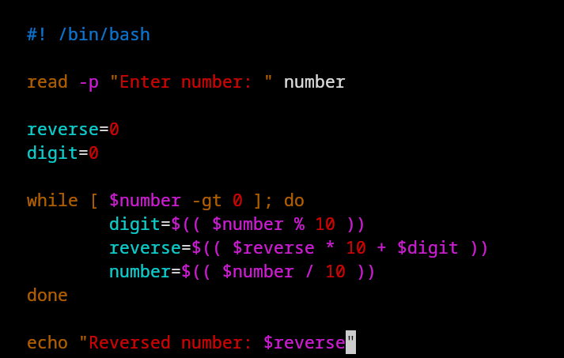

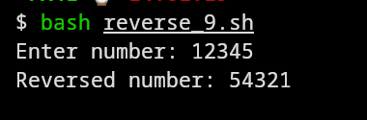

**10. Write a shell script to reverse a user-defined string. Hint: use pipe operator and rev.**

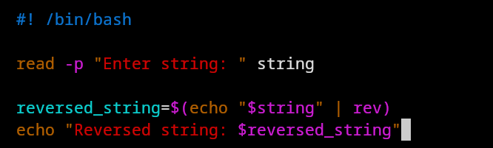

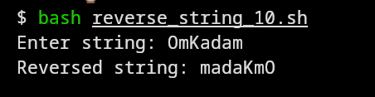

**11. Write a shell script to reverse the word order in a list of strings. For example, if the input is Hello World, output should be World Hello.**

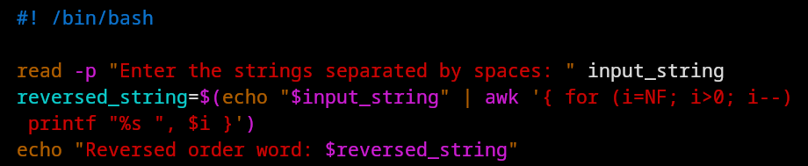

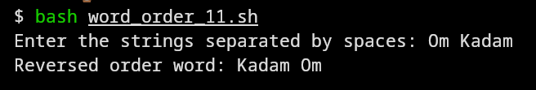

**12. Write a shell script using case to either create a new file or delete an existing file.**

**bash script.sh --create newfile.txt should create this new file and bash script.sh --delete newfile.txt should delete this existing file.**

**Display "Not a valid argument" if neither --create nor --delete is specified. Hint: Use case**

**$1 to determine the argument option.**

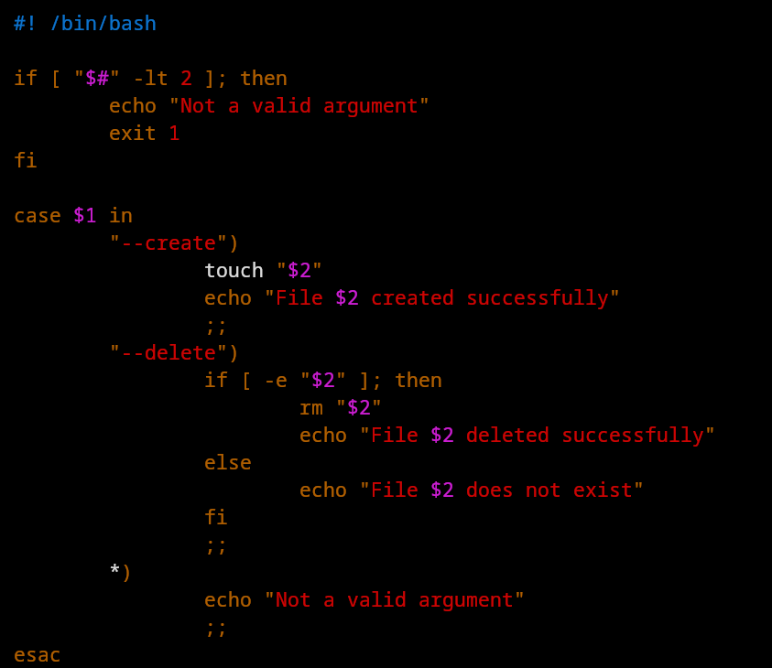

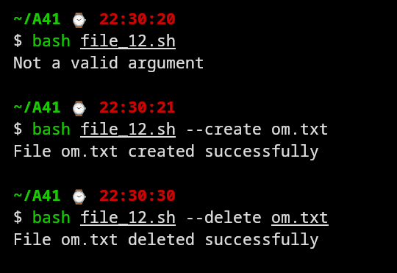

**13. Write a shell script for the following: accept a city name from user; using case statements, determine the country of this city. Provide multiple city names in each case statement.**

**Example of one case could be "Mumbai" | "Delhi" | "Pune") echo "The country is India" ;;**

**If options do not match, write one case statement as *) echo "To be added soon!".**

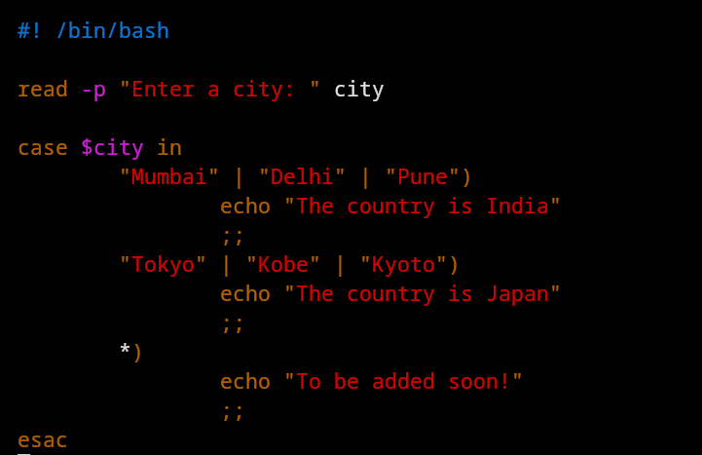

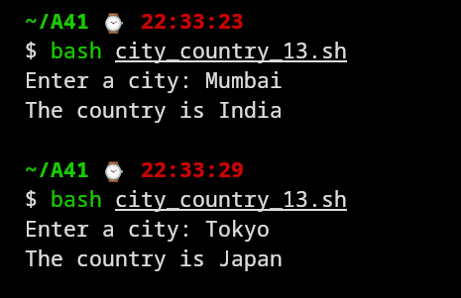

**14. Write a shell script to convert user-given temperature in Celsius to Fahrenheit using bash calculator.**

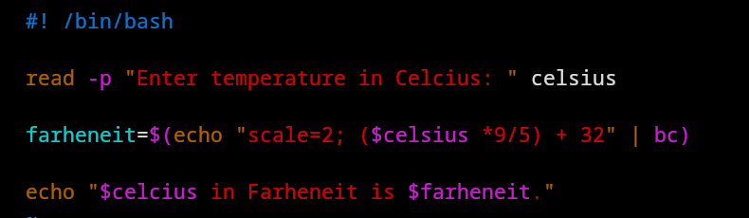

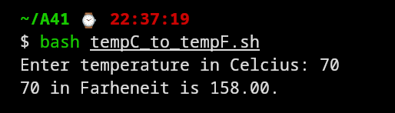

**15. Write a shell script to take two numbers from the user and choose arithmetic operations, i.e. add, subtract, multiply, divide, exponentiation, and return the corresponding result. Use case statements and bash calculator.**

